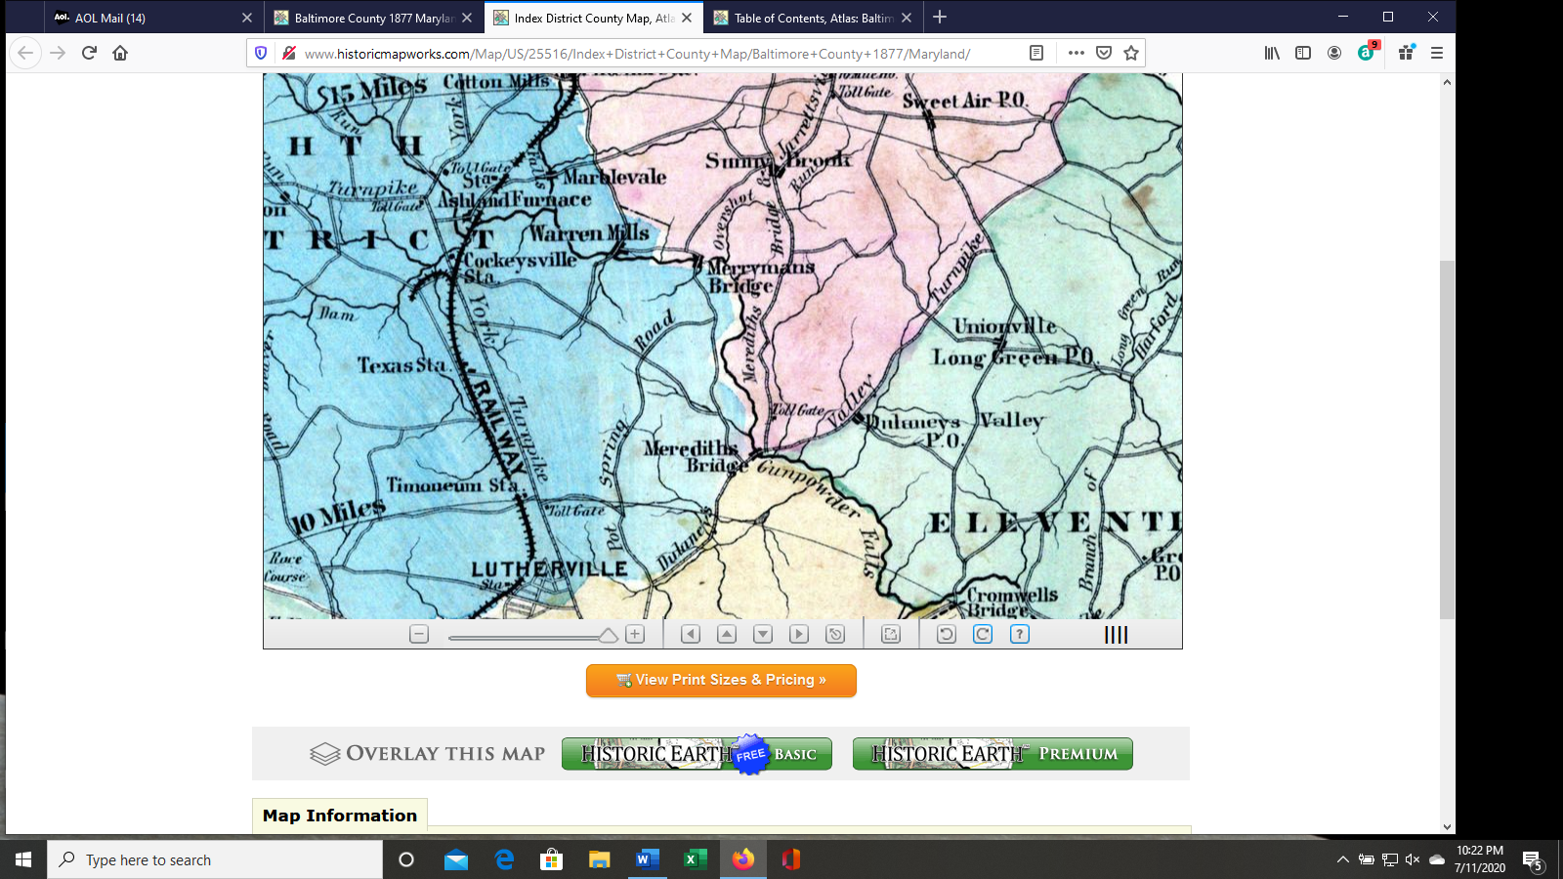

Excerpt of Index to District County Map.

1877 Atlas of Baltimore County, Maryland.

G.M. Hopkins, c.e.

G.M. Hopkins and Company.

Baltimore, MD. 1877.

**1898 Dulaney’s Valley Turnpike Bosley Road Meredith’s Bridge Road to Jarrettsville Turnpike**

**2020 Dulaney Valley Road Old Bosley Road Jarrettsville Pike**

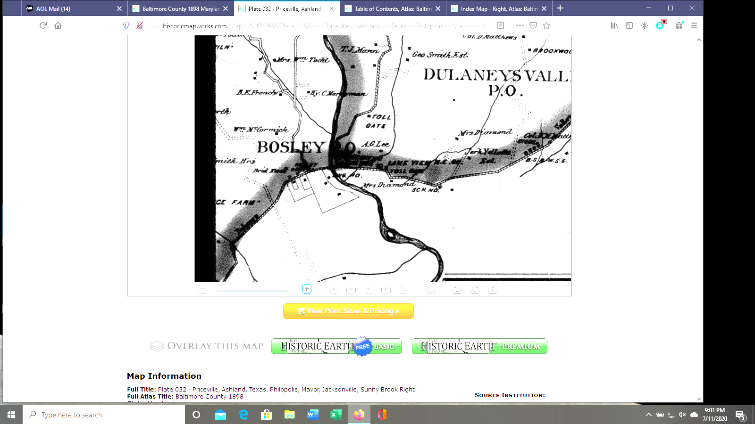

Excerpt of Plate 32.

***1898 Baltimore County, Maryland Atlas.***

G.W. and W.S. Bromley, c.e.

G.W. Bromley and Company.

Philadelphia, PA. 1898.

This is the best I was able to do in the way of a map for the “town” of Bosley.

**1898 Dulany’s Valley Turnpike Bosley Road Meredith’s Bridge Road to Jarrettsville Turnpike**

**2020 Dulaney Valley Road Old Bosley Road Jarrettsville Pike**